Anti-Bullying
At Dens Road Primary School and Nursery, we believe that our school values of Happiness, Nurture, Aspiration, Respect and Integrity should run through every aspect of school life, and this includes how we relate, respond and react to each other.

We value the opinion of everybody within our school community, so we have spoken to children, parents and carers, teachers and other staff members before putting together our anti-bullying policy. We hope that everyone can continue to work together to help to maintain a positive ethos throughout the school and the community.

Everything we do in Dens Road is underpinned by our Vision, Values and Aims:

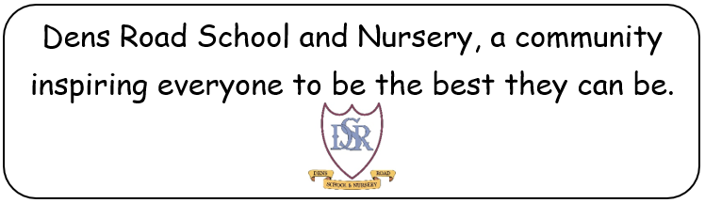

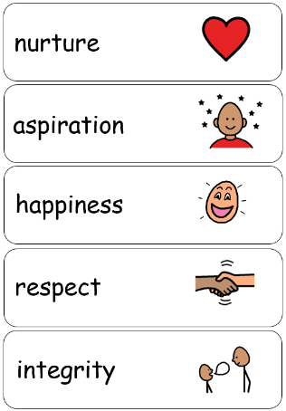

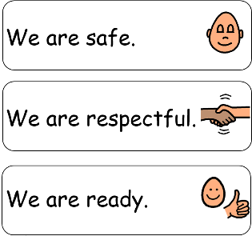


Together, we believe that bullying can include:
Name calling
Targeting or threatening others
Hitting, kicking or pushing

Stealing from someone
Hurting the feelings of others on purpose
Being unkind

Being unkind because somebody is different
Making fun of people
Hurtful comments online or on social media

Not including others
Breaking other people’s things





If you feel that any of these things are happening to you, or your child, then you need to speak to an adult about it. It is important that you do this as soon as possible rather than trying to deal with a situation on your own.

Who can help?

If you are worried about something or something has happened to you or the child that you look after, there are various different people that you can talk to:

Head Teacher – Mr Daniel Albayati

Depute Head Teacher – Mrs Jenna Lux

School and Family Development Worker – Mrs Denise Gormley

Teacher or Key Worker

Any other adult that you feel safe to share with

The quicker that you share it with us, the quicker we can try to resolve any problems.

Our Ethos
At Dens Road Primary School and Nursery, we aim to create a culture that celebrates positive relationships based on our school visions, values and aims. These are expectations all around the school, be that in the classroom, the playground or any other area.

These are repeatedly shared with the children throughout lessons and assemblies to ensure that the messages are embedded into everything that we do.


We are proud to celebrate the many different cultures that we have within our school. We ensure that we treat everyone equally and that everybody’s opinions are listened to and valued. This is also an expectation for the children and everybody else in our school community.

We have our Relationships for Wellbeing and Learning Policy which is used throughout the school that supports our ethos.

Through these actions, and by using a range of strategies and approaches, we aim to prevent bullying behaviour before it occurs.

What we do if an incident occurs
If an incident is reported to us, we will ensure that we respond as quickly as we can, and that we treat every situation with the same sense of importance. The safety and wellbeing of the children in our school is paramount to everything that we do.

We will always investigate each incident fully, inform families of affected parties, and monitor situations and provide continuing support as long as needed.


We believe that restorative conversations are the most effective way to resolve conflicts. We will ask the children (and families if necessary) to come together to talk through any issues and decide on an appropriate course of action moving forward that all parties are happy with.

We will also continue to support children following any incidents so that they continue to feel comfortable and safe in the school environment. Our Anti Bullying Coordinator – Mr Paul McBean will check in with victims and those displaying bullying behaviours incidents.
We record and monitor incidents of bullying at a whole school level in order to keep track of all information and to ensure that all members of staff are aware of any issues.
If you would like any further information on bullying, please ask us, or visit Scotland’s Anti-Bullying Service website at: www.respectme.org.uk

