Date: October 2025
Review Date: October 2027
1. Purpose and Commitment
At Dens Road Primary School and Nursery, we are committed to creating a safe, inclusive, and respectful learning environment for all. We believe that every child and adult in our school community has the right to be treated fairly, with dignity and respect.


Everything we do is underpinned by our clear Vision, Values and Aims:


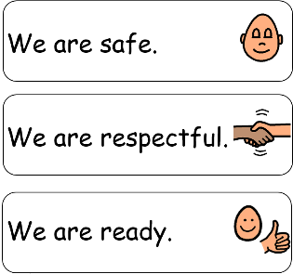
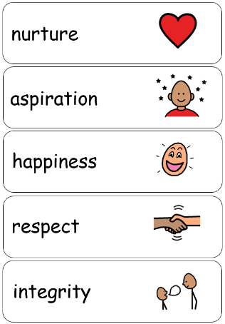
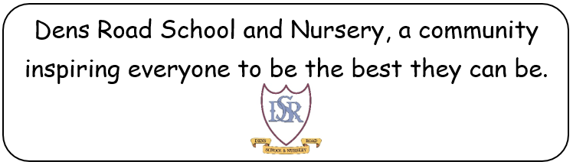

We actively oppose all forms of racism — including prejudice, discrimination, bias, and racial harassment — and we work together to promote understanding, respect, and equality.
Our approach is guided by:
- The Equality Act 2010
- UN Convention on the Rights of the Child (UNCRC) (We currently have our Silver Rights Respecting Schools Award and are working towards Gold).
- Respect for All: The National Approach to Anti-Bullying for Scotland’s Children and Young People (2017)
- Schools - addressing racism and racist incidents: guidance Schools - addressing racism and racist incidents: guidance - gov.scot
- Education Scotland’s Anti-Racism in Education Programme (AREP)
- Our Calls for Action and Breaking the Mould Principals (created by children at Dens Road – See Appendix 1)
2. Aims
Our aims are to:
- Promote positive relationships and celebrate cultural and racial diversity in line with our relationships policy.
- Ensure that racism is never tolerated and always challenged.
- Educate pupils about equality, fairness, dignity and justice.
- Support children and families affected by racism.
- Ensure staff are confident in recognising, responding to, and recording racist incidents.
- Promote UNCRC across Dens Road Primary School.

3. Definition of Racism
We define racism as:
“Any behaviour, language, or practice that disadvantages, excludes, or demeans a person or group based on their race, colour, nationality, culture, or ethnic or national origin.”
This includes:
- Direct or indirect discrimination
- Racial bullying or harassment
- Use of racial slurs or stereotypes
- Microaggressions or exclusionary behaviour

4. Prevention and Education
We teach anti-racism through:
- Curriculum: Embedding equality and diversity across our curriculum and promoting representation in books, IDL topic areas, and displays.
- Assemblies and Events: Celebrating cultural and religious heritage or festivals and discussing fairness, kindness, and respect. E.g. Eid celebrations, Christmas, Language of the Month, Our Dens Road Song, Mother Language Day, Culture Day
- Staff Training: All staff will receive training on recognising and addressing racism and unconscious bias. Mrs D’All currently taking part in the Building Racial Literacy CLPL and will share this learning with staff team. Continuous work with the Children’s Parliament is also crucial to develop staff confidence in challenging racism in our schools.
- Pupil Voice: Encouraging children to speak up, share experiences, and contribute to an inclusive school culture.

5. Responding to Racist Incidents
All racist incidents will be:
- Taken seriously and investigated promptly.
- Recorded using the school’s incident reporting system on Seemis.
- Reported to the Head Teacher and Depute Head Teacher and, if necessary, to the local authority.
- Addressed through education, restorative conversation, and support for all involved with member of the SLT.
- Our Anti Racism Coordinators are: Mr Paul McBean and Mrs Laura D’All. Part of this role includes checking in with children who have been effected by racism and also with the children who displayed any racist behaviours.
We do not tolerate racism, but we also believe in supporting learning and growth. Our response will always aim to:
- Protect the person targeted.
- Educate those responsible.
- Reinforce the school’s values and aims.
Parents and carers will be informed of serious incidents, and these will be recorded on Seemis as a Racist Incident.

6. Support for Pupils and Families
- Any pupil or parent who experiences or witnesses' racism will be listened to and supported.
- Our Anti Racism Coordinators will check in with those displaying these behaviours and those effected after any incidents as part of their role.
- We will provide opportunities for children to discuss their feelings safely.
- The school will work with families and community partners to ensure understanding and resolution.

7. Monitoring and Evaluation
- The Senior Leadership Team will review incident records regularly to identify patterns and inform school improvement.
- Feedback from pupils, parents, and staff will shape ongoing actions.
- The policy will be reviewed every two years (or sooner if required).

8. Linked Policies
This policy should be read alongside the following policies at Dens Road PS:
- Relationships and Behaviour Policy
- Child Protection and Safeguarding Policy
- Anti-Bullying Policy

9. Key Messages for Pupils
- Everyone is welcome here.
- Everyone deserves respect.
- Racism is never okay.
- If you see or hear racism, tell an adult you trust.




Appendix 1:
