Relationships for Wellbeing and Learning
Our Relationships for Wellbeing and Learning Vision Statement
Our approaches to managing behaviour are rooted in wellbeing and relationships. Positive relationships are instrumental to ensuring the best possible learning environment for all children at Dens Road School and Nursery. We aim to achieve a sense of belonging for all our children, working with the whole community to build positive relationships and recognise individual strengths and needs. At Dens Road Primary and Nursery, we aim to create an atmosphere of mutual respect and collective responsibility. Children, parents/carers and staff all have an important part to play in creating and sustaining this positive ethos.
We focus on our aims and values that we all live by every day.
Our Values Our Aims

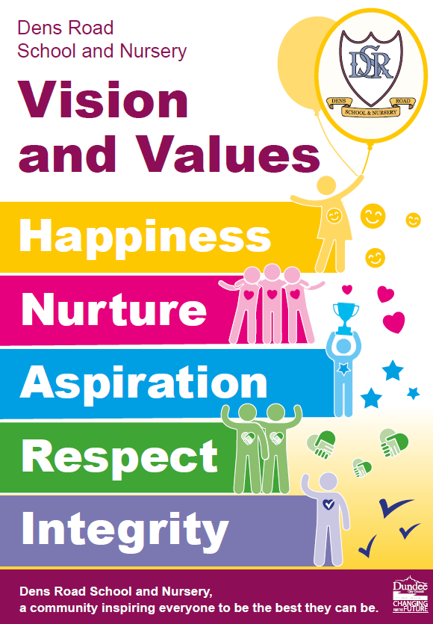
Be safe
Be respectful
Be honest

Our Approaches – Universal and Targeted Support, Consistencies and Relentless Routines
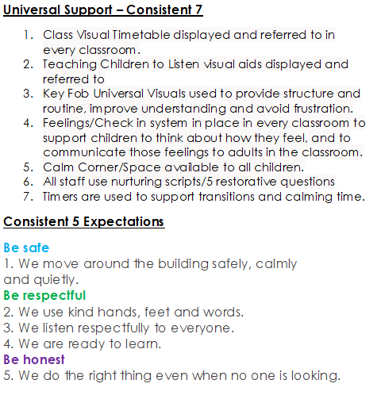
Targeted Support
5 Point Scale
Calm Kits
Calm Sequences
Individual Schedules
Now and Then Boards

Relentless Routines
All children are in their line (single file or pairs) and ready to enter the building when the bell rings.
Quiet lines and fantastic walking at all times (inside and out).
During class time, one child from each class can visit the toilet at a time.
A healthy eating culture is promoted by all staff. This is followed up with families if necessary.
All learning spaces are kept tidy and looked after with care.
All children follow our Dens Road Dinner Hall Routines.

Our Approaches – Recognition and Supporting Learners
Recognition | Supporting Learners  Steps and Action | Nurturing Scripts | FIVE Restorative Questions
- Star of the Week – awarded fortnightly at assembly to recognise achievements and successes across the curriculum.  - Hot Chocolate Fridays – class teachers nominate children fortnightly who consistently go “Over and Above” in line with our school values.​  - Positive note home – any member of staff can give this recognition.  - Recognition Boards – used in class to recognise children meeting a social or learning target.  - House Points​ – house system is promoted at assemblies and in class. Any member of staff can award house points in recognition of children following our aims (We are safe, respectful and honest).  - Positive phone call home - SLT​ to contact home to recognise and share success with parents/carers.  - Seesaw – teachers and the SLT share children’s successes and achievements through Seesaw. | - Reminder of Expectations and /or Redirection  gentle encouragement  a reminder of the expectations - we are ready, respectful and honest  - Private Reminder  A reminder of the expectations delivered privately - we are ready, respectful and honest.  - Final Opportunity  30 second script to be used  ‘I’ve noticed that…’ link to being safe, respectful, honest.  ‘I need you to – give 2 options and explain what they need to do.  ‘Remember when…’ note a time of success.  Close, ‘I know you can do this’.  Walk away – ‘thank you’  - Time Out / Positive Redirection  Give the child a chance to regulate away from others. At this point the child may require a change of environment to regulate.  This can take place in the classroom calm corner, buddy classroom, HT/DHT/SFDW Office or an agreed room.  In the playground, time out will involve buddying with a member of support staff or taking time out on a bench.  Script to be used: I need you to…. Go to a calm space/take a deep breath/have some thinking time  - Phone call to parent/carer  SLT to contact parent/carer where appropriate.  - Repair/Fix  A restorative conversation should take place at an appropriate time e.g. before the next lesson and when the child is calm enough to engage. | Connecting and Defusing  Offer choice:  Instead of, ‘It’s time to read your book.’ Try, ‘Which of these books would you like to read?’  Limit use of non-negotiable words:  ‘Is it alright with you if…’  ‘How do you feel about…’  ‘What do you feel ready for?’  Share responsibility:  ‘us’ ‘we’ ‘let’s’ ‘together’  Running Commentaries  Describe and say ‘what you see’ with regards to a child’s emotions.  - ‘You look happy today, you have a big smile on your face.’  - I’m wondering if you feel sad today. You’ve been very quiet.  - ‘You are really angry about… try something from the calm kit to help you feel better.’  - I can see that you aren’t ready, what do you need to be ready?  Language of belonging  - ‘You are a valued member of the Dens Road Family.’  - ‘You’re a Dens Road Learner.’  - ‘You belong and are an important member of our classroom.’  - ‘I’ll be thinking about you and keeping you in mind.’  - ‘You are important to me.’ | - What happened?  - What were you thinking or feeling at the time?  - Who is involved/been affected?  - How will we fix it or what should we do to put things right?  - How can we do things differently in the future?

‘Children need people, not punishment. It is time we gave them what they need to succeed, not simply what we feel they deserve. Exclusion and heavy sanctions rarely meet the needs of the child.’ Paul Dix

