Relationships Policy
Our Relationships for Wellbeing and Learning Vision Statement
Positive relationships and a commitment to children’s rights are instrumental to ensuring the best possible learning environment for all children at Dens Road School and Nursery. We aim to achieve a sense of belonging for all our children, working with the whole community to build positive relationships and recognise individual strengths and needs. At Dens Road Primary and Nursery, we aim to create an atmosphere of mutual respect and collective responsibility through a rights-based approach. Children, parents/carers and staff all have an important part to play in creating and sustaining this positive ethos.
We focus on our Vision, Values and Aims that we all live by every day.


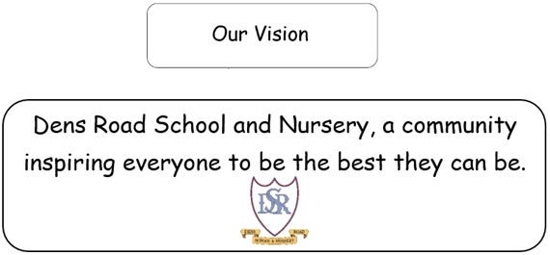
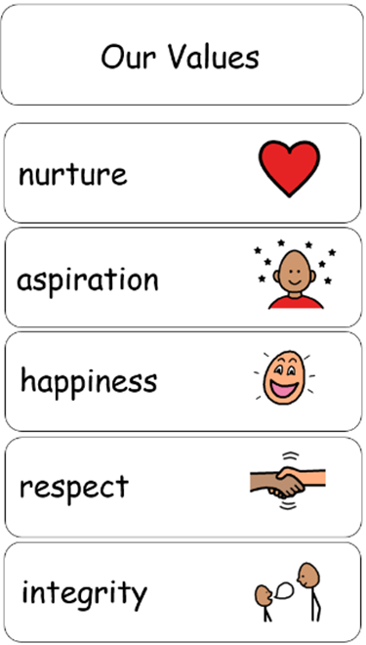

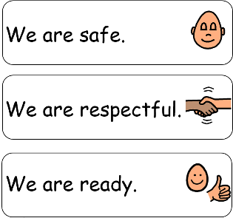

UNCRC

At Dens Road Primary, our Vision, Values and Aims are closely linked to the principles and Articles of the United Nations Convention on the Rights of the Child (UNCRC).
We believe that every child has the right to feel safe, respected, and valued within our school community.
Wellbeing and positive relationships are at the heart of everything we do. We aim to build an inclusive and caring school culture where everyone feels they belong and can learn together. (Articles 2, 3, 6, 23 and 31)
Every child has the right to an education that helps them learn, grow and succeed.(Article 28)
All children have the right to support that helps them make the most of their learning and reach their full potential. (Article 29)

Our Approaches – Universal or Targeted Support and Structure/Routines
In line with The Dundee Standard of Inclusive Practice

Universal Support
- Class visual timetable displayed and referred to daily in every classroom.
- Class visual timetable to be shared with parents/carers each day via Seesaw.
- ‘Teaching children to Listen’ visual aids displayed and consistently used to reinforce expectations.
- Universal key-fob visuals used to support structure, routine, and understanding.
- Feelings/Check-in system in all classrooms to help children recognise and communicate emotions.
- Calm Space available in every classroom for all children to access when needed.
- Restorative approaches – all staff use consistent scripting and restorative questions.
- Timers used to support smooth transitions and calm time.
- Calm Kits and Fix-It Folders available in every classroom to promote regulation and problem-solving.

Targeted Support
- Individual visual timetables
- Individual calm sequences
- Now & Next boards
- Nurture-based approaches used to support identified children requiring additional help with emotional regulation or relationships.
- Individualised support plans in place for children with specific social, emotional, or behavioural needs.
- Small group interventions (e.g. nurture groups, social skills, friendship groups) delivered to build confidence and resilience.
- Regular check-ins with key adults to provide consistency, reassurance, and positive relationship building.
- Collaboration with parents/carers to ensure consistency between home and school approaches.
- Partnership working with external agencies (e.g. Educational Psychology, CAMHS, Inclusion Team) where required.
- Staff monitoring and review of progress to ensure interventions remain effective and responsive to need.

Routines/Structure
- Quiet lines & wonderful walking at all times in all parts of our school
- All children are in their lines (in pairs) and ready to enter the building when the bell rings
- During class time, one child from each class can visit the toilet at a time
- We are a healthy eating school and promote healthy snacks – see healthy eating policy
- All learning spaces are tidy, well organised and looked after with care by all
- Calm transitions between activities supported by adult presence
- Rehearse, remind, reinforce – routines are continually practiced until they become habits
Our Approaches – Recognition and Supporting Learners

Recognition and Reinforcement | Supporting Learners  Steps and Action | Nurturing Scripts | FIVE Restorative Questions
- All staff have consistently high expectations of all learners.  - Values and Aims – children are supported to understand our values and aims through assemblies, learning experiences and restorative conversations.  - Right of the Month – children are supported to understand their rights through assemblies and learning experiences.  - Star of the Week – awarded fortnightly at assembly to recognise achievements and successes across the curriculum.  - Fruity Fridays – class teachers nominate children fortnightly who consistently go “Over and Above” in line with our school values and aims.​  - Positive note home – any member of staff can give this recognition.  - House Points​ – house system is promoted at assemblies and in class. Any member of staff can award house points in recognition of children following our aims (We are safe, respectful and ready).  - Positive phone call home - SLT​ to contact home to recognise and share success with parents/carers.  - Seesaw – teachers and the SLT share children’s successes and achievements through Seesaw. | - Reminder of Expectations and /or Redirection  gentle encouragement  a reminder of the expectations - we are safe, respectful & ready  - Private Reminder  A reminder of the expectations delivered privately - we are safe, respectful & ready  - Final Opportunity  30 second script to be used  ‘I’ve noticed that…’ link to being safe, respectful, ready.  ‘I need you to – give 2 options and explain what they need to do.  ‘Remember when…’ note a time of success.  Close, ‘I know you can do this’.  Walk away – ‘thank you’  - Positive Redirection  Give the child a chance to regulate away from others. At this point the child may require some time in the classroom calm corner.  In the playground, this may involve buddying with a member of support staff.  Script to be used: I need you to…. Go to a calm space/take a deep breath/have some thinking time  - Phone call to parent/carer  SLT to contact parent/carer where appropriate.  - Repair/Fix  A restorative conversation should take place at an appropriate time e.g. before the next lesson and when the child is calm/regulated enough to engage. | Connecting and Defusing  • Offer choice - Instead of: "It's time to read your book." Try: "Which of these books would you like to read?"  • Limit use of non-negotiable words:  • "Is it alright with you if ..."  • "How do you feel about ..."  • "What do you feel ready for?"  • Share responsibility - use: "us", "we", "let's", "together"  Running Commentaries  • Describe and say what you see with regards to a child's emotions.  • "You look happy today; you have a big smile on your face."  • "I'm wondering if you feel sad today. You've been very quiet."  • "You are really angry about ... try something from the calm kit to help you feel better."  • "I can see that you aren't ready - what do you need to be ready?"  Language of Belonging  • "You are a valued member of the Dens Road Family."  • "You're a Dens Road Learner."  • "You belong and are an important member of our classroom."  • "I'll be thinking about you and keeping you in mind."  • "You are important to me."  Big Deal / Little Deal  • "This feels like a big deal - what do you need to feel better / make it a little deal?"  • "This is just a little deal because we can ..."  • "Maybe we can just ..."  • "There we go - you see, that was not a big deal."  • "That was just a little deal - there's always something that works, isn't there?"  • "There's always something we can do."  Hard to Do / Easy to Do  • "This is quite hard/easy to do, isn't it?"  • "It's hard to do because ..."  • "OK ... so we need to make a plan ..."  • "Maybe you should ask for help?"  • "Great - that was hard to do but you asked for help and we did it."  • "There's always something that works, isn't there?"  • "There's always something we can do."  Ready / Not Ready  • "I can see you're not ready ..."  • "What do you need to feel ready?"  • "I can wait for you."  • "I'll know you are ready when you ..."  • "OK - you're not ready. No problem; just let me know when you're ready."  Interrupting Teaching  • "I'm interested in what you have to say; I'll hear about this after I've finished teaching."  • "That sounds interesting - we can plan in time to talk about this later."  • "One voice."  Collaborative Problem Solving  1. Empathy - fully understand their concerns and perspective.  • "I've noticed that you are talking over me and shouting out when I am teaching. What's going on? What's up?"  2. Problem definition - place your concern on the table.  • "This is a big deal for me because my job is teaching and learning, and I am finding it hard to do my job well when you interrupt."  3. Invitation - explore solutions that are workable and mutually satisfactory.  • "I wonder if there's a way to address both concerns."  30 Second Script  • "I've noticed that ..." (link to being safe, respectful, ready).  • "I need you to ..." (give two options and explain what they need to do).  • "Remember when ..." (note a time of success).  • Close: "I know you can do this."  • Walk away: "Thank you." | - What happened?  - What were you thinking or feeling at the time?  - Who is involved/been affected?  - How will we fix it or what should we do to put things right?  - How can we do things differently in the future?

‘Children need people, not punishment. It is time we gave them what they need to succeed, not simply what we feel they deserve. Exclusion and heavy sanctions rarely meet the needs of the child.’ Paul Dix

