Dundee Primary School

School Improvement Report
Session 2022-2023



Dundee Primary School
Main Road,
Dundee. DD20 16PQ
Tel 436666
Email: dundeeps@dundeecity.gov.uk

This document shares and celebrates the improvements in our School and embraces all ages and stages. It is based upon our School Improvement Plan for session 2021 - 2022

Vision
Dens Road School and Nursery, a community inspiring everyone to the best they can be.
Values
Happiness
Nurture
Aspiration
Respect
Integrity

Aims
We aim to be the best we can be and live our values in all that we do. We aim to create a safe, inclusive and inspiring environment where everyone matters. We work together as a team with everyone within our community to ensure all learners are inspired, challenged and supported in their learning journey.
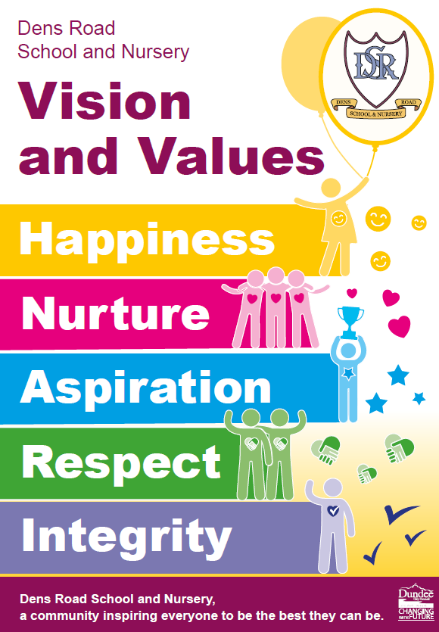

Context of the School:

Dens Road Primary School and Nursery sits in the East of the City of Dundee. It sits within an area of deprivation with approximately 79% of the population living in SIMD 1 and 2. 43% of our learners are bilingual and approximately 30% of our learners speak English as an additional language. We currently have nine primary classes, two nursery classes and our roll for next session is approx. 290 (including nursery). At Dens Road Primary School, there is a relentless focus on closing the poverty related attainment gap, improving outcomes for all children and raising attainment in literacy and numeracy.

Attainment Data 2022 - 2023
(percentages)
 | Reading | Writing | Talking and Listening | Numeracy
Primary 1  (CFE Early Level) | 71% | 73% | 85% | 88%
Primary 4  (CFE 1st Level) | 88% | 81% | 94% | 81%
Primary 7  (CFE 2nd Level) | 88% | 84% | 94% | 88%

Review of Improvement Progress for Session 2022-2023

School Improvement Priority 1:

IMPROVEMENT PRIORITY 1 - LEADERSHIP and MANAGEMENT
Progress and Impact:

Embedding VVAs
Our Vison, Values and Aims are explicit and implicit across the school and nursery. They are linked within new policies and documents that have been created such as the Relationships and Anti-Bullying policies. Continuously referring to the VVAs during assemblies and in class has ensured children are aware of expectations. Values are spoken about and reflected on each week when staff nominate children for Star Awards and Over and Above recognition. Values posters are visible around the school and nursery and are referred to daily by all staff. Pupils understand the VVAs and can confidently discuss these with others. The VVAs have also successfully been introduced in child friendly language in Nursery and P1. The child friendly posters are displayed in P1 classrooms and on the nursery floor - they are also available on all digital documentation. This has supported staff to incorporate the values into children’s learning experiences.

Review of Relationships and Anti-Bullying Policies
Our new relationships and anti-bullying policies have been developed in consultation with staff, pupils and parents/carers. Relevant training opportunities have taken place for staff to support the development of these policies e.g. trauma informed practice, de-escalation, good practice checklist, universal and targeted support. The updated policies have been shared with all stakeholders and will be fully implemented next session.

Pupil Voice
Children in Dens Road School and Nursery have continued to be given the opportunity to contribute and influence the life and work of the school/nursery through a range of leadership groups - digital leaders, Dignity in School group, Big Voice Little People, pupil council, school and house captains, buddies.

In the classroom, children’s opinions are sought on what makes an excellent lesson as part of the learning and teaching blueprint and teachers plan lessons in response to this.

There has been a focus on ensuring children’s voice is at the centre of all Team Around the Child Meetings. Children are now given the opportunity to join TATC meetings or talk to a Meeting Buddy prior to and following the meeting to share their feelings and opinions. Pupil voice is also a key feature of the ongoing development of individual plans.

Pupil Council has begun to use questioning from 'wee HGIOS' to provoke discussion and gather learner views.

Self-evaluation and Quality Assurance
Dens Road School and Nursery continues to have a robust Quality Assurance calendar in place which is followed rigorously. Teachers across each stage meet regularly with the Senior Leadership Team to review planning, tracking and assessment. Our self-evaluation processes include scrutiny of qualitative data along with teacher judgement to identify appropriate interventions for children. Staff are fully engaged with this process which has resulted in improvements at individual, class and whole school level.

Next Steps:

VVAs
Continue to strengthen the VVAs through ongoing promotion with all stakeholders.

Relationships and Anti-bullying Policies
Fully implement and embed new polices into the daily life of the school. There will be ongoing monitoring and evaluation of new policies to ensure a shared understanding of expectations.

Self-evaluation and Quality Assurance
Involve all stakeholders in self-evaluation activities and continue to link quality improvement activity to HGIOS 4 and focus on key aspects of learners’ successes and achievements.

Pupil Voice
Pupil voice needs to become more visible across the school with opportunities for learners to share their thoughts and opinions regularly in every classroom. More work still needs to be done in giving children ownership of their learning by providing opportunities to self-assess and take responsibility. Next session, we will implement a whole school approach to pupil leadership, linking this to “wee HGIOS,” ensuring that all learners have shared ownership of self-evaluation which focuses on improving the life and work of the school.

School Improvement Priority 2:

IMPROVEMENT PRIORITY 2 - LEARNING PROVISION

Progress and Impact:

Learning Teaching and Assessment
The Learning, Teaching and Assessment Blueprint has ensured a shared understanding of expectations across all aspects of learning, teaching and assessment. The blueprint is now well established within the school and is used as part of quality assurance and moderation processes as well as a point of reference for teachers.

All teaching staff are now trained in Explicitly Teaching Writing (ETW) and some staff have engaged with Tools for Writing (TfW) training. This has increased staff confidence in this area and we have started to see a positive impact on attainment. Following ETW and TfW training, writing guidelines have been created to ensure there is a consistent approach to teaching and assessing writing across the school.

There has continued to be a focus on ensuring robust tracking of progress and attainment across literacy, numeracy & Health and Wellbeing. Wellbeing webs and the Glasgow Motivation and Wellbeing profile are in the early stages of implementation. They are being used to gather data on children’s wellbeing and teachers are planning lessons and inputs in response to this.

The Daily 15 has been successfully implemented across the whole school and children now have access to 15 minutes of outdoor activity on at least three occasions per week in addition to two hours of Physical Education. Teachers are beginning to use the newly developed Physical Education planning documents to plan progressive PE lessons.

Digital Learning
This session, we achieved our digital schools award and were recognised as being a pioneer among schools where digital learning and teaching is supporting our children prepare for living and working in the 21st Century. The use of flexible learning spaces and the empowerment of children and staff were also recognised as key strengths. There have been major improvements this session with all classes now having a larger number of devices at their disposal as part of learning and teaching to offer opportunities for digital skills development and to enhance learning experiences. Additional devices to deliver other aspects of technologies are available as are a wide range of support materials. Ongoing training opportunities are also available for all staff.

The profile of STEM learning has increased over the course of the year and staff are more aware of experiences and opportunities they can offer to learners. Staff confidence levels have improved in delivering STEM experiences. Cluster moderation held for reading and science has helped share what is happening across the cluster schools. This in turn has highlighted all the good work that is taking place as well as opportunities which can be further explored by our STEM lead and QAMSO next session.

Next Steps:

Raising attainment in writing
Embed Explicitly Teaching Writing and Tools for Writing in the classroom to raise achievement in writing at all stages.

Digital/STEM Learning
Work with Digital Learning Education Support Officer to deliver whole staff training to ensure staff remain confident in delivering high quality teaching and learning in this area. Continue to embed and extend learning experiences using digital technologies in all classes around the school including an established digital area in each room. Issue a standard for digital learning to set our expectations at different stages. Continue to develop training, resources and delivery of learning experiences in all aspects of STEM. Explore all opportunities to share good practice and share with SLT staff from cluster moderation to further improve our own practice.

Teaching and Learning
To raise achievement in numeracy, further develop pedagogical practices through whole staff training in Retrieval Practice.

HWB
PE planning documents supported by PEPAS group to be fully implemented and embedded throughout the whole school. Embed Daily 15 and approaches to assessing children’s wellbeing. We need to build on HWB data gathered and then use this to further meet the needs of the children.
School Improvement Priority 3:

IMPROVEMENT PRIORITY 3 - SUCCESSES and ACHIEVEMENTS

Progress and Impact:

The Addressing Barriers to Learning (ABLe) process is now more streamlined with teaching staff being fully responsible for evaluating individual plans and ensuring input from learners. Staff have received training on trauma informed practice, de-escalation and universal support. This has increased staff confidence and enabled the needs of all learners to be better met. GMWP assessments are being used across the year to assess needs of learners and support the identification and delivery of support and input where needed.

Dignity in School (DiS) programme has been successful in building the knowledge of targeted classes in this area. Identified classes have worked with the DiS group and there is a group of pupil reps who have worked with other schools in the city and nationally. This has supported the implementation of a rights-based approach across the school.

We have started to gather data to specifically monitor the progress of targeted groups based around the three Ps (Presence, Progress and Participation). This will be developed further next session.

Dens Road continues to place a high value on partnership working to ensure our children and their families receive the right support at the right time. Our work in this area was recognised at the Outstanding Service and Commitment awards (OSCAs) in June 2023 where we were awarded an OSCA for improving services through partnership working.
Next Steps:

Continue to build on understanding of the ABLe process and support staff in this where needed. Development and implementation of a flexible learning space which will be used for targeted time for identified learners alongside opportunities for fluid use.

Develop a more robust process for assessing and tracking the progress of targeted groups.

Further develop processes for assessing children’s wellbeing at class level. Fully implement the use of the Glasgow Motivation and Wellbeing Profile in P4-7 ensuring that assessment information informs improvements in children’s wellbeing. Follow on work with Dignity in School and begin to reintroduce more elements of the UNCRC process.

Improvement Priorities for Session 2023-2024

- Presence

Implementing a consistent approach to relationships and restorative practice across the school which promotes presence and participation of all learners will remain a key priority next session. Work will be completed to ensure the principles of the UN Convention on the Rights of the Child are embedded into our ethos and curriculum.
- Progress

Raising attainment for all learners will remain a high priority and is the responsibility of all staff. Improvement in this regard will involve rigorous tracking of attainment over time, robust assessment and moderation processes, and the continuing development of teachers’ confidence, capacity and skills.
- Participation

Implementation of a flexible learning space which will be used for targeted time for identified learners alongside opportunities for fluid use. This will ensure the complexity of the demographic across the school and nursery will be effectively supported leading to better outcomes.

Please submit this completed document by email to your link Education Officer.

Please visit www.careinspectorate.com or https://education.gov.scot/what-we-do/inspection-and-review/reports for Care Inspectorate or HMIE Inspection Reports.

https://parentzone.org.uk/

Further Information can be found at:

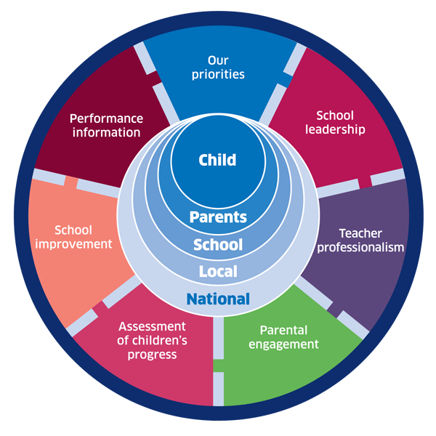 | 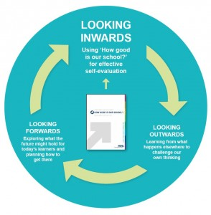 |  |   Dundee Education Plan  https://www.dundeecity.gov.uk/sites/default/files/publications/annual_education_plan_2017-18.pdf
National Improvement Framework  http://www.gov.scot/Publications/2016/01/8314 | HGIOS 4 Self-evaluation https://education.gov.scot/improvement/Documents/Frameworks_SelfEvaluation/FRWK2_NIHeditHGIOS/FRWK2_HGIOS4.pdf | Tayside Plan C&FS  External Link ' Tayside_Plan 1a.pdf'

